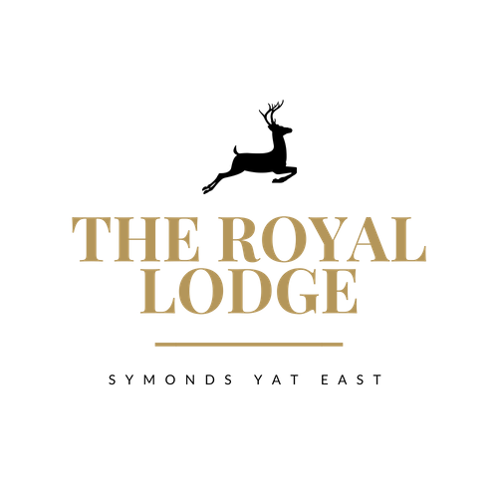

***SNACK MENU***

|  |  |
| --- | --- |
| ***Walkers Lunch****: Soup of the day and choice of sandwich (W)* | *£17.95* |

***Sandwiches £12.95***

Pastrami & Cheese, Djon Mustard, Gem Lettuce (W, M, Mu)

Cheese & Pickle, Gem lettuce (W, M)

Tuna Mayonnaise, Cucumber (F, M, W)

Baked Ham & Tomato, Gem lettuce (W)

Roast Chicken Salad (W)

Vegan Meatball & Cheese (W)

Coronation Chickpea, Gem lettuce (W)

***Choice of Brown, White or Gluten Free Bread, £1.00 surcharge for gluten free.   
Served with Coleslaw and a Handful of Plain Crisps.***

***ALLERGENS:***

*C=Celery, L=Lupin, N=Nut, Sul=Sulphur Dioxide, Cr=Crustacean, M=Milk, So=Soya P=Peanut, W=Wheat, E=Egg, Mol=Mollusc, S=Sesame, V=Vegetarian, F=Fish, Mu=Mustard*

An optional 10% service charge will be added to your bill



***SNACK MENU***

|  |  |
| --- | --- |
| ***Walkers Lunch****: Soup of the day and choice of sandwich (W)* | *£17.95* |

***Sandwiches £12.95***

Pastrami & Cheese, Djon Mustard, Gem Lettuce (W, M, Mu)

Cheese & Pickle, Gem lettuce (W, M)

Tuna Mayonnaise, Cucumber (F, M, W)

Baked Ham & Tomato, Gem lettuce (W)

Roast Chicken Salad (W)

Vegan Meatball & Cheese (W)

Coronation Chickpea, Gem lettuce (W)

***Choice of Brown, White or Gluten Free Bread, £1.00 surcharge for gluten free.   
Served with Coleslaw and a Handful of Plain Crisps.***

***ALLERGENS:***

*C=Celery, L=Lupin, N=Nut, Sul=Sulphur Dioxide, Cr=Crustacean, M=Milk, So=Soya P=Peanut, W=Wheat, E=Egg, Mol=Mollusc, S=Sesame, V=Vegetarian, F=Fish, Mu=Mustard*

An optional 10% service charge will be added to your bill