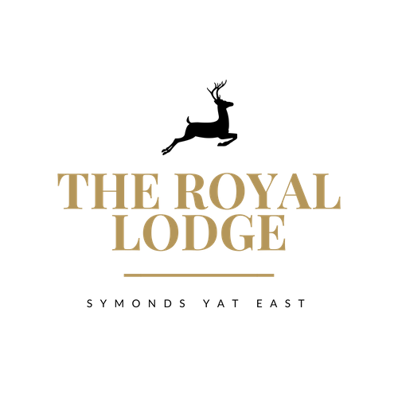

THE LODGE MENU

ALL DINNER INCLUSIVE GUESTS PLEASE NOTE THE SUPPLEMENTS ON SOME DISHES

STARTERS
Homemade Vegetable Soup, Freshly Baked Roll £10.95 (W)
Chicken Tikka Terrine, Mint Yogurt, Crispy Onions £10.95 (W)
Devilled Whitebait, Roasted Garlic Aioli £10.95 (W, F, M)
Baked Camembert, Honey & Focaccia Toast £12.95 (£2 Supplement) (W, M)
Quinoa Falafel, Avocado Tahini Dressing (vegan) £10.95 (Vegan)
Salt & Pepper Tofu, Coriander Pesto, Roasted Red Pepper Sauce (vegan) £10.95
MAIN COURSES
Lamb Rogan Josh, Roasted Garlic & Lemon Rice, Naan Bread £26.95 (£5 Supplement) (W, M)
Supreme of Chicken, Mushroom, & Spinach Tagliatelle £21.95 (W, M)
Pork Sausage & Plum Stuffed Loin of Pork, Thyme Roasted Baby
Potatoes, Braised Red Cabbage, Rich Pan Gravy. £24.95 (£3 Supplement) (W, M)
Blacked Cajun Fillet of Salmon, Mango & Mint Salsa, Garlic & Lemon rice £24.95 (£3 Supplement) (F)
Cider Battered Haddock & House Chips, Mushy Peas, Tartar Sauce £21.95 (W, F)
House 6oz Burger, House Chips, Battered Gherkin, Relish, Coleslaw £21.95 (W)
House Vegan Burger, Battered Gherkin, Relish, House Chips, Coleslaw £21.95 (W)
Vegan Tagliatelle & Tomato Meatballs, Garlic Bread (vegan) £21.95 (W, Vegan)
Beef & Ale Pie, Roasted Vegetables, Creamy Mash Potatoes, Rich Pan Gravy £21.95 (W, M, Sul)
Vegan Spiced Cauliflower, Spinach & Lentil Pie, Roasted Vegetables, Mash Potatoes (Vegan) £21.95
Trio of Award-Winning Sausages, Mash Potato, Garden Peas and Gravy £19.95 (W, M)
8oz Flat Iron Steak, cooked medium, served with our House Chips, Chimichurri Sauce, Grilled Tomato
& Portobello Mushroom. £24.95 (£3 Supplement)

ALLERGENS
C=Celery, L=Lupin, N=Nut, Sul=Sulphur Dioxide, Cr=Crustacean, M=Milk, So=Soya P=Peanut, W=Wheat, E=Egg, Mol=Mollusc, S=Sesame, V=Vegetarian, F=Fish, Mu=Mustard

An optional 10% service charge will be added to your bill

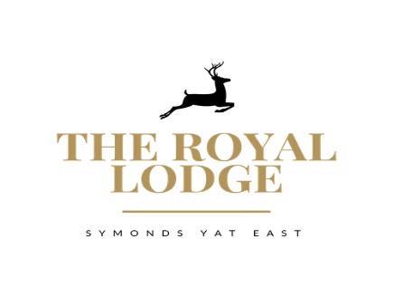

SMALL PLATES (UNDER 12 & OVER 65) £12.95
Vegan Tagliatelle & Tomato Meatballs, Garlic Bread (W)
Roasted Chicken breast, Vegetables, Mashed potatoes, Pan Gravy (M)
Cheeseburger, House chips, Heinz Baked beans or Garden Peas (W)
Duo of Sausages, Mashed Potatoes, Heinz Baked Beans or Garden Peas (M)
Battered Chicken Nuggets, House Chips, Heinz Baked Beans or Garden Peas (W)

SIDES & SAUCES
House Chips £4.95 Cheesy Chips £5.95
Garlic Bread £4.95 (W) Cheesy Garlic Bread £5.95 (W, E)
Battered Onion Rings £4.95 (W, E) Chimichurri £2.95

DESSERTS
Pear & Plum Crumble £10.95 (M)
Chocolate & Banana Bread & Butter pudding £10.95 (W, M)
Treacle Tart with Clotted Cream £10.95 (W, M)
Chocolate Fondant & Vanilla Ice Cream £10.95 (M)
Chocolate Brownie Sundae £10.95 (M)
Trio of Ice Creams with Chocolate Wafer £9.95 (M)
Trio of Sorbets with Wafer £9.95
Trio of Cheese Plate, Cheddar, Brie and Blue Cheese with Crackers, Fruit and Chutney £12.95 (£2 Supplement) (W, M)
Children’s 2 Scoop Ice Cream (M) £7.95

An optional 10% service charge will be added to your bill

LUNCHTIME MENU

SANDWICHES £12.95 / BAGUETTES £13.95
All Sandwiches & Baguettes are served with Coleslaw & Crisps
Pastrami & Cheese, Djon Mustard, Gem Lettuce (W, M, Mu)
Cheese & Pickle, Gem lettuce (W, M)
Tuna Mayonnaise, Cucumber (F, M, W)
Baked Ham & Tomato, Gem lettuce (W)
Roast Chicken Salad (W)
Vegan Meatball & Cheese (W)
Coronation Chickpea, Gem lettuce (W)

WALKERS LUNCH
Soup Of the Day with a Sandwich £17.95 (W)

SHIRE LUNCH
Choice of Cheese, Ham or Both, Served with Pickled Onions, Sausage Roll,
Mixed Salad and White or Brown Baguette £18.95 (M, W, E, Mu, C, Sul)

An optional 10% service charge will be added to your bill

ALLERGENS
C=Celery, L=Lupin, N=Nut, Sul=Sulphur Dioxide, Cr=Crustacean, M=Milk, So=Soya P=Peanut, W=Wheat, E=Egg, Mol=Mollusc, S=Sesame, V=Vegetarian, F=Fish, Mu=Mustard

An optional 10% service charge will be added to your bill

