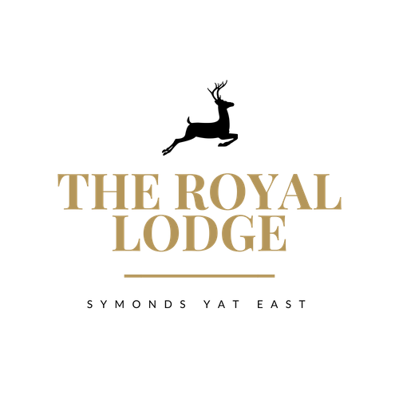

***GARDEN TEA MENU*** ***Coffee & Cake (GF, E, V)***

*slice of either Victoria Sponge, Chocolate Brownie or Lemon Drizzle with a Hot Beverage*

**£7.50**

***Tea & Toasted Teacakes (M, W, V)***

*Two Teacakes with Strawberry Jam, Butter, and a Hot Beverage*

**£8.95**

***Royal Lodge Cream Tea with Hot Beverage of Your Choice (M, W, V)***

*Includes two Fruit Scones, served with Clotted Cream, Strawberry or Raspberry Jam & Butter*

**£12.95**

***Sparkling Cream Tea (M, W, V)***

*Includes Two Fruit Scones, Served with Clotted Cream, Strawberry Jam & Butter.   
Accompanied with a Hot Beverage of your choice & glass of Prosecco*

**£20.95**

***Royal Lodge Afternoon Tea (M, W, E)***

*A choice of half a Homemade Sandwich, Fruit Scone, Clotted Cream, Strawberry or Raspberry Jam, Butter and two types of cake, miniature sausage roll and slice of quiche.*

*Accompanied with a Hot Beverage of your choice*

**£21.95**

***Sparkling Afternoon Tea (M, W, E)***

*A choice of Half a Homemade Sandwich, Fruit Scone, Clotted Cream, Strawberry or Raspberry Jam, Butter and two types of cake, miniature sausage roll and slice of quiche.*

*Accompanied with a Hot Beverage of your choice and a glass of Prosecco*

**£29.95**

*Sandwich Filling Choices: -*

Pastrami & Swiss Cheese, Djon Mustard, Gem Lettuce, Cheese & Pickle, Gem lettuce

Tuna Mayonnaise, Cucumber, Baked Ham & Tomato, Gem lettuce

Roast Chicken Salad, Vegan Meatball & Cheese

Coronation Chickpea, Gem lettuce

*Served on either White or Wholemeal Bread, Gluten Free Also Available (£1.00 surcharge)*

**ALLERGENS:**

C=Celery, L=Lupin, N=Nut, Sul=Sulphur Dioxide, Cr=Crustacean, M=Milk, So=Soya, P=Peanut, W=Wheat, E=Egg, Mol=Mollusc, S=Sesame, V=Vegetarian, F=Fish, Mu=Mustard:

*An optional 10% service charge will be added to your bill*