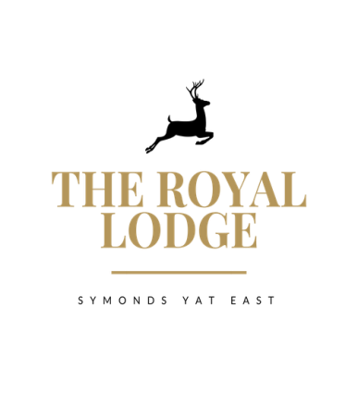

***THE LODGE’S TABLE D’HOTE MENU***

*STARTER ONLY £9.95, MAIN ONLY £18.95, DESSERT ONLY £9.95*

***3 COURSES £37.95***

***STARTERS***

Chicken Liver Pate, Onion Jam, Brown Toast **(W, Sul, M)**

Pan Fried Garlic and Thyme Mushrooms, Parmesan, Soft Poached Egg, on Focaccia **(M, W)**

Classic Prawn Cocktail, Lettuce **(Cr, W, M,)**

Breaded Brie, Cranberry Sauce, Salad, Balsamic Reduction **(W, M, Sul, V, E)**

Roasted Florets of Cauliflower Satay **(So, Vegan)**

***MAINS***

*Mains are served with your choice of* ***Chips (W),******New Potatoes (M)*** *or* ***Dauphinoise Potatoes(M*)** Except Dishes marked with **#**

Cajun Chicken Breast, Garlic and Cajun Sauce, Mixed Salad

**#**Beetroot & Butternut Squash Wellington, Salad & Spring Onion, Red Pepper, Couscous ***(W, M, V, S, So, Vegan)***

Double Homemade Welsh Black Beef Burger in Brioche Bun   
Mature Cheddar, Smoked Bacon, Mayonnaise, Lettuce, Tomato Relish ***(C, W, M, Mu, Sul, E)***

Breaded Scampi Mixed Salad, Garden Peas & Tartar Sauce ***(W, M, Cr)***

|  |  |
| --- | --- |
| ***#***Spaghetti Bolognaise, served with Parmesan Shavings and Garlic Bread **(C, Sul, M, W, E)** |  |

***DESSERTS***

White Chocolate and Raspberry Cheesecake ***(V, M, W)***

Lodge, Baked Apple Pie with Choice of Custard, Cream Or Ice Cream ***(M, W)***

Apple & Mixed Berry Crumble with Cream, Custard, Ice cream ***(M, GF, V)***

Chocolate Fondant with Vanilla Ice Cream ***(GF, E, M, V)***

Trio of ice cream ***(GF, V, E, M)*** or Sorbet ***(Vegan)***

Chocolate Brownie Ice Cream Sundae **(M, GF)**

**ALLERGENS:**

C=Celery, L=Lupin, N=Nut, Sul=Sulphur Dioxide, Cr=Crustacean, M=Milk, So=Soya P=Peanut, W=Wheat, E=Egg, Mol=Mollusc, S=Sesame, V=Vegetarian, F=Fish, Mu=Mustard**:**

An optional 10% service charge will be added to your bill