

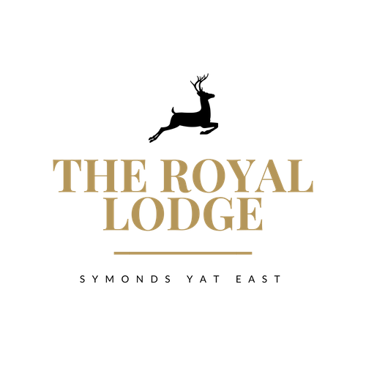**Super October Specials**

**10oz Prime Ribeye Steak,** Garlic & Chive Mushrooms, Grilled Tomato, Homemade Worcester Sauce Onion Rings   
 your choice of Chips, New or Dauphinoise Potato.   
Served with Peppercorn Sauce **(M, W) £38.95**

**10oz 28 Day Aged Sirloin Steak**, Garlic & Chive Mushrooms, Grilled Tomato, Worcester Sauce Onion Rings, your choice of Chips, New or Dauphinoise Potato Served with Pepper Sauce **(M) £33.95**

**Lamb Rump**,Fondant Potato, Baby Carrots, Tenderstem Broccoli and Red Currant Sauce **(Sul, M) £27.95**

***Pressed Local Pork Belly****, Baby Carrots, Tenderstem Broccoli, Fondant Potato and Cider Sauce (****M, Sul, C) £25.95***

***Soy Tuna Steak****, Pak Choi, Red Onion and Tomato Salsa Soy Sauce New Potatoes* ***(F, So) £25.95***

**An optional 10% service charge will be added to your bill  
ALLERGENS   
C=Celery, L=Lupin, N=Nut, Sul=Sulphur Dioxide, Cr=Crustacean, M=Milk, So=Soya P=Peanut, W=Wheat, E=Egg, Mol=Mollusc, S=Sesame, V=Vegetarian, F=Fish, Mu=Mustard:**