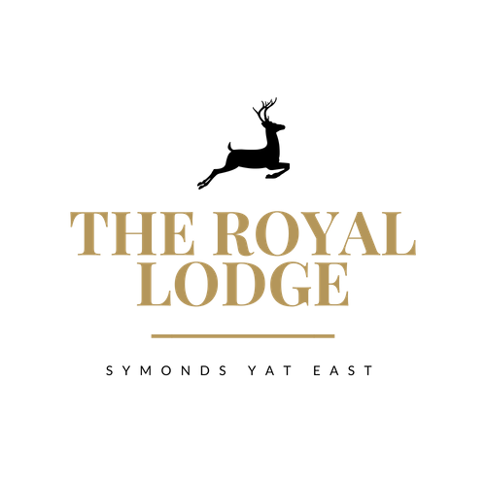

SNACK MENU

Walkers Lunch: Vegetable Soup and Choice of Sandwich | £14.95
Baguettes / Sandwiches
Colliers Mature Cheddar and Pickle Chutney (M, Mu, C, W) | £10.95
Home Honey Roasted Ham and Mustard (W, Sul, Mu) | £11.95
Tuna & Cucumber with Mayonnaise (W, F, E) | £11.95
Roast Beef and Horseradish (W, Sul, Mu, M) | £11.95
Turkey, Stuffing and Cranberry (W, Sul, M, E) | £11.95
Hummus, Red Pepper and Rocket (W, Sul, S, V) | £10.95
Cucumber and Chive Cream Cheese (M, V) | £10.95
Choice of Brown, White or Gluten Free Bread, £1.00 surcharge for gluten free. Served with Mixed Salad and a Handful of Plain Crisps.

Lodge Shire Lunch (M,W,E,Mu,C,Sul)
Choice of Home Cooked Honey Roast Ham or Mature Cheddar or Both, Served with Pickled Onions, Grated Carrot, Sausage Roll and Tomato Salad with White or Brown Crusty Baguette | £16.95

ALLERGENS:
C=Celery, L=Lupin, N=Nut, Sul=Sulphur Dioxide, Cr=Crustacean, M=Milk, So=Soya P=Peanut, W=Wheat, E=Egg, Mol=Mollusc, S=Sesame, V=Vegetarian, F=Fish, Mu=Mustard

An optional 10% service charge will be added to your bill

SNACK MENU
Walkers Lunch: Vegetable Soup and Choice of Sandwich | £14.95
Baguettes / Sandwiches
Colliers Mature Cheddar and Pickle Chutney (M, Mu, C, W) | £10.95
Home Honey Roasted Ham and Mustard (W, Sul, Mu) | £11.95
Tuna and Cucumber with Mayonnaise (W, F, E) | £11.95
Roast Beef and Horseradish (W, Sul, Mu, M) | £11.95
Turkey, Stuffing and Cranberry (W, Sul, M, E) | £11.95
Hummus, Red Pepper and Rocket (W, Sul, S, V) | £10.95
Cucumber and Chive Cream Cheese (M, V) | £10.95
Choice of Brown, White or Gluten Free Bread, £1.00 surcharge for gluten free. Served with Mixed Salad and a Handful of Plain Crisps.

Lodge Shire Lunch (M,W,E,Mu,C,Sul)
Choice of Home Cooked Honey Roast Ham or Mature Cheddar or Both, Served with Pickled Onions, Grated Carrot, Sausage Roll and Tomato Salad with White or Brown Crusty Baguette | £16.95

ALLERGENS:
C=Celery, L=Lupin, N=Nut, Sul=Sulphur Dioxide, Cr=Crustacean, M=Milk, So=Soya P=Peanut, W=Wheat, E=Egg, Mol=Mollusc, S=Sesame, V=Vegetarian, F=Fish, Mu=Mustard

An optional 10% service charge will be added to your bill

