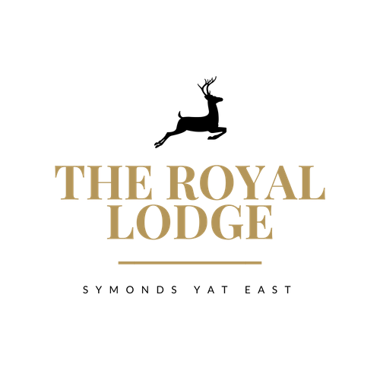

THE LODGE MENU

STARTERS
Chicken Liver Pate, Onion Jam, Brown Toast (W, Sul, M) | £9.95
Prawn and Crayfish Cocktail, Lettuce and Brown Bread (Cr, F, W, M,) | £9.95
Winter Vegetable Soup with Crusty Bread (C, V, W, M) | £8.95
Baby Carrot and Tenderstem Broccoli, Leek Wraps with Citrus Mayo (Vegan) | £9.95
Warm Scotch Egg with Mustard Mayonnaise (M, Sul, E, W) | £9.95
Gambas Ajillo, sautéed tiger prawns with garlic, chilli & parsley (Cr, M, Sul) | £12.95
Pan Fried Garlic and Thyme Mushrooms, Cream Sauce, Soft Poached Egg and Parmesan Shavings on Toasted Focaccia (M, W ,E) | £11.95
Roasted Florets of Cauliflower Satay (So) | £9.95
Warm Salad of Pink Radish, Tenderstem Broccoli, Spring Onion, Sesame, Beansprouts, Watermelon, Pak Choi & Hoisin Sauce (S, So) | £9.95

SIDE ORDERS
Chips (W) | £4.50
Chips with Cheese (W, M) | £4.95
Garlic Bread (V, W, M) | £4.50
Garlic Bread with Cheese (V, W,M) | £4.95

CHILDREN’S MENU
All children’s menu items are served with a choice of Chips (W) or New Potatoes
Breaded Chicken Breast Peas or Beans (E, W, M) | £9.95
Pork Sausages, Peas or Beans (L, E, W, M, Mu, Sul) | £9.95
Breaded Scampi, Peas or Beans (E, F, W, M, Cr) | £9.95
Welsh Black Beef Burger Brioche Bun, Cheese, Bacon (W, E, M) | £9.95
Mushroom, Courgette & Sweet Potato Risotto (Vegan) | £9.95
Spaghetti Bolognese, served with Parmesan and Garlic Bread (C, Sul, M, W, E) | £10.95

ALLERGENS
C=Celery, L=Lupin, N=Nut, Sul=Sulphur Dioxide, Cr=Crustacean, M=Milk, So=Soya P=Peanut, W=Wheat, E=Egg, Mol=Mollusc, S=Sesame, V=Vegetarian, F=Fish, Mu=Mustard

An optional 10% service charge will be added to your bill

MAIN COURSES
All mains are served with a choice of Chips (W), New Potatoes or Dauphinoise Potatoes(M)
Beef, Ale & Mushroom Pie Mixed Vegetables, Gravy (Sul, M, E, W) | £17.95
Chicken Balti Pie, Bombay Potatoes and Cumin Carrots (E, W) | £18.95
10oz 28 Day Aged Sirloin Steak Creamy Garlic & Chive Mushrooms, Grilled Tomato (M)  (Add Pepper Sauce - £2.50) (Sul, M) | £29.95
Home Cooked Honey and Mustard Roasted Ham, Fried Eggs and Peas (E, Mu) | £15.95
South Indian Fish Curry (F, Cr, W)  King Prawn and Tandoori Monkfish, gently simmered in a mildly spiced Indian Gravy with Lentils and Curry Leaves, Coconut Milk, Rice and Poppadom, Chutneys, Naan Bread | £26.95
Spaghetti Bolognaise, served with Parmesan Shavings and Garlic Bread (C, Sul, M, W, E) | £17.95
Beetroot and Butternut Squash Wellington, Salad and Pepper Couscous (W, So, V, Vegan) | £18.95
Mushroom, Courgette & Sweet Potato and Cheese Risotto (C, Sul, Vegan) | £17.95
Moroccan Mixed Vegetable Tagine (Vegan) and Flatbread (W,M) | £17.95
Oven Roasted Hake Mixed Vegetables and  Prawn and Mushroom White Wine Sauce (W, Cr, F, M) | £23.95
Slow Roasted Pork Belly Parsnip Puree, Roasted Parsnips, Mixed Vegetables, Cider and Apple Gravy (M, Sul, C) | £23.95
Slow Roasted Boned and Rolled Shoulder of Lamb, Mixed Vegetables and Mint Gravy (Sul) | £24.95
Wye Valley Battered Haddock Peas, Tartare Sauce and Mixed Salad (W, M, F) | £18.95

LODGE DESSERT MENU

Chocolate Fondant with Vanilla Ice Cream (GF, E, M, V) | £9.95
Trio of Ice Cream (GF, V) OR Trio of Sorbet (V, Vegan) | £7.50
Coffee & Rum Brulee with Vanilla Shortbread (M, W, E, V) | £9.95
Apple & Mixed Berry Crumble with Cream, Custard or Ice Cream (M, E, V GF) | £9.95
Malteser Cheesecake with Malteser crumb (W, M, V) | £9.95
Coconut and Cardamom Rice Pudding with Plum Compote (Vegan) | £9.95
Royal Lodge Cheese Slate Selection of five local Cheeses with Pepper and Sea Salt Butter, Quince, Fruit Chutney, Grapes, Celery and Mixed Biscuits (M, C, W, Mu, S, N, V) | £14.95

ALLERGENS
C=Celery, L=Lupin, N=Nut, Sul=Sulphur Dioxide, Cr=Crustacean, M=Milk, So=Soya P=Peanut, W=Wheat, E=Egg, Mol=Mollusc, S=Sesame, V=Vegetarian, F=Fish, Mu=Mustard
An optional 10% service charge will be added to your bill

