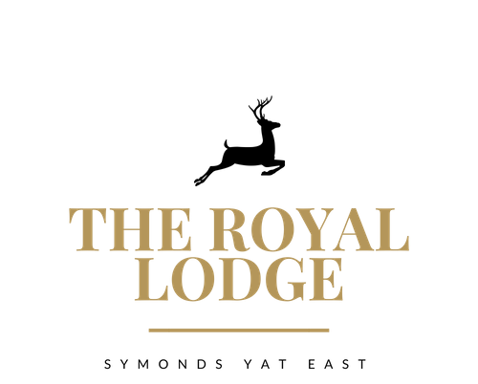

GARDEN TEA MENU
Coffee & Cake
slice of either Victoria Sponge, Carrot Cake or Lemon Drizzle with a Hot Beverage
£5.95

Tea & Toasted Teacakes
Two Teacakes with Strawberry Jam, Butter, and a Hot Beverage
£7.95

Royal Lodge Cream Tea with Hot Beverage of Your Choice
Includes two Fruit Scones, served with Clotted Cream, Strawberry or Raspberry Jam & Butter
£11.95 PP

Sparkling Cream Tea
Includes Two Fruit Scones, Served with Clotted Cream, Strawberry Jam & Butter.
Accompanied with a Hot Beverage of your choice & glass of Prosecco
£19.95 PP

Royal Lodge Afternoon Tea
A choice of half a Homemade Sandwich, Fruit Scone, Clotted Cream, Strawberry or Raspberry Jam, Butter and two types of cake, miniature sausage roll and slice of quiche.
Accompanied with a Hot Beverage of your choice
£19.95 PP

Sparkling Afternoon Tea
A choice of Half a Homemade Sandwich, Fruit Scone, Clotted Cream, Strawberry or Raspberry Jam, Butter and two types of cake, miniature sausage roll and slice of quiche.
Accompanied with a Hot Beverage of your choice and a glass of Prosecco
£27.95 PP
Sandwich Filling Choices:-
- Tuna Mayonnaise | - Salmon and Cream Cheese
- Colliers Cheddar and Pickle | - Ham and Mustard
- Beef and Horseradish | - Ham and Cheese
- Cucumber and Chive Cream Cheese | - Hummus and Peppers

Served on either White or Wholemeal Bread, Gluten Free Also Available (£0.50 surcharge)
Allergens: C, E, G, M, Mu, N, P, S, SUL

ALLERGENS:

C=Celery, L=Lupin, N=Nut, Sul=Sulphur Dioxide, Cr=Crustacean, M=Milk, So=Soya, P=Peanut, W=Wheat, E=Egg, Mol=Mollusc, S=Sesame, V=Vegetarian, F=Fish, Mu=Mustard:

An optional 10% service charge will be added to your bill

