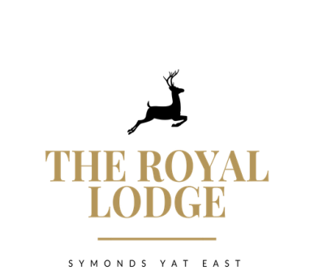

THE LODGE’S TABLE D’HOTE MENU

STARTER ONLY £9.95, MAIN ONLY £18.95, DESSERT ONLY £9.95
3 COURSES £37.95

STARTERS
Chicken Liver Pate, Onion Jam, Brown Toast (W, Sul, M)
Pan Fried Garlic and Thyme Mushrooms on Focaccia (M, W)
Prawn and Crayfish Cocktail, Lettuce (Cr, F, W, M,)
Breaded Brie, Cranberry Sauce, Salad, Balsamic Reduction (W, M, Sul, V)
Baby Carrot and Tender Stem Broccoli Leek Wraps with Citrus Mayo (Vegan)
Roasted Florets of Cauliflower Satay (So, Vegan)
MAINS

Mains are served with your choice of Chips (W), New Potatoes or Dauphinoise Potatoes(M)
Cajun Chicken Breast, Garlic and Cajun Sauce, Mixed Salad
Beetroot & Butternut Squash Wellington, Mixed Salad & Spring Onion, Red Pepper, Couscous (W, M, V, So, Vegan)
Double Homemade Welsh Black Beef Burger in Brioche Bun
Mature Cheddar, Smoked Bacon, Mayonnaise, Lettuce, Tomato Relish (W, E, M, Mu, Sul)
Breaded Scampi Mixed Salad, Garden Peas & Tartar Sauce (F, W, M)
Wye Valley Beer Battered Haddock Mixed Salad, Garden Peas & Tartar Sauce (F, W, M)
North Indian Vegetable Curry, Rice and Poppadom (Vegan)
DESSERTS
Malteser Cheesecake with Malteser crumb (V, M, W)
Coffee & Rum Brûlée with Vanilla Shortbread (M, W, E)
Apple & Mixed Berry Crumble with Cream, Custard, Ice cream (M, GF, E, V)
Chocolate Fondant with Vanilla Ice Cream (GF, E, M, V)
Trio of ice cream (GF, V, E, M) or Sorbet (Vegan)
Coconut & Cardamom Rice Pudding with Plum Compote (Vegan)
ALLERGENS:
C=Celery, L=Lupin, N=Nut, Sul=Sulphur Dioxide, Cr=Crustacean, M=Milk, So=Soya P=Peanut, W=Wheat, E=Egg, Mol=Mollusc, S=Sesame, V=Vegetarian, F=Fish, Mu=Mustard:

An optional 10% service charge will be added to your bill

