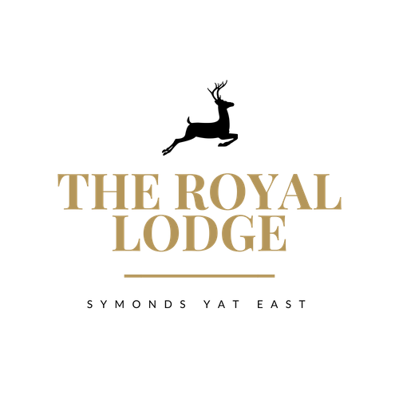

SNACK MENU
Baguettes
Colliers Mature Cheddar & Pickle Chutney (M, Mu, C, W)£11.95
Home Honey Roasted Ham & Mustard (W, Sul, Mu) £11.95
Tuna & Mayonnaise, Cucumber (W, F, E) £11.95
Roast Beef & Horseradish (W, Sul, Mu, M) £11.95
Avocado, Rocket, Roasted Peppers (V, W) £11.95
A Choice of Brown, White or Gluten Free Bread Served with Mixed Seasonal Salad and a Handful of Plain Crisps.
Lodge Shire Lunch (M,W,E,Mu,C,Sul)
Choice of Home Cooked Honey Roast Ham or Mature Cheddar or Both, Served with Pickled Onions, Grated Carrot, Pork pie and Mixed Salad with White or Brown Crusty Baguette £16.95
Vegan Lodge Shire Lunch
Vegan cheddar cheese, pickle onion, mixed salad,
sun blushed tomato onion jam vegan quiche, pear,
baguette £16.95
Bowl of Homemade Chips £4.50 Cheesy Chips £4.95 SOUP
Tomato and Basil soup (C, V, VEGAN) Crusty Bread (W, M) £8.50
ALLERGENS:
C=Celery, L=Lupin, N=Nut, Sul=Sulphur Dioxide, Cr=Crustacean, M=Milk, So=Soya P=Peanut, W=Wheat, E=Egg, Mol=Mollusc, S=Sesame, V=Vegetarian, F=Fish, Mu=Mustard
An Optional 10% service charge will be added to your bill

SNACK MENU
Baguettes
Colliers Mature Cheddar & Pickle Chutney (M, Mu, C, W)£11.95
Home Honey Roasted Ham & Mustard (W, Sul, Mu) £11.95
Tuna & Mayonnaise, Cucumber (W, F, E) £11.95
Roast Beef & Horseradish (W, Sul, Mu, M) £11.95
Avocado, Rocket, Roasted Peppers (V, W) £11.95
A Choice of Brown, White or Gluten Free Bread Served with Mixed Seasonal Salad and a Handful of Plain Crisps.
Lodge Shire Lunch (M,W,E,Mu,C,Sul)
Choice of Home Cooked Honey Roast Ham or Mature Cheddar or Both, Served with Pickled Onions, Grated Carrot, Pork pie and Mixed Salad with White or Brown Crusty Baguette £16.95
Vegan Lodge Shire Lunch
Vegan cheddar cheese, pickle onion, mixed salad,
sun blushed tomato onion jam vegan quiche, pear,
baguette £16.95
Bowl of Homemade Chips £4.50 Cheesy Chips £4.95 SOUP
Tomato and Basil soup (C, V, VEGAN) Crusty Bread (W, M) £8.50
ALLERGENS:
C=Celery, L=Lupin, N=Nut, Sul=Sulphur Dioxide, Cr=Crustacean, M=Milk, So=Soya P=Peanut, W=Wheat, E=Egg, Mol=Mollusc, S=Sesame, V=Vegetarian, F=Fish, Mu=Mustard
An Optional 10% service charge will be added to your bill

