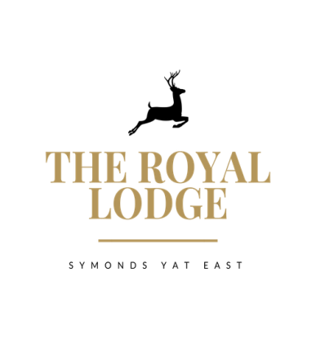

THE LODGE’S DEVIL TABLE D’HOTE MENU
STARTER ONLY £9.95; MAIN ONLY £18.95; DESSERT ONLY £8.95
STARTERS
Chicken Liver Pate, Onion Jam, Toast (W, Sul, M)
Herb Crusted Mushroom Stack Sun Blushed Tomatoes and Red Pepper, rocket (M, W)
Prawn and Crayfish Cocktail, Little Gem (Cr, F, W, M,)
Warm Scotch Egg, Chilli Jam and crispy leeks (M, Sul, E,W)
Breaded Brie, Cranberry Jam, Salad, balsamic reduction (W, M, Sul)
Fig, pepper and Mushroom Couscous salad with dressing (Vegan)
MAINS
Mains are served with Your Choice of Chips (W), New, Sauteed or Dauphinoise Potatoes(M)
Roasted Turkey, Yorkshire pudding, mixed seasonal vegetables, roasted potatoes, gravy (W,M,E)
Roasted Topside of Beef, Yorkshire pudding, mixed seasonal vegetables, roasted potatoes, gravy (W,M,E)
Lodge Nut Roast, mixed seasonal vegetables, roasted potatoes, Gravy (Vegan, N, Sul)
Double Homemade Welsh Black Beef Burger in Brioche Bun (W, E, M, Mu, Sul)
Mature Cheddar, Smoked Bacon, Mayonnaise, Gem Lettuce, onion jam
Breaded Scampi Mixed Salad, Garden Peas & Tartar Sauce (F, G, M)
Wye Valley Beer Battered Fish Fillet Mixed Salad, Garden Peas & Tartar Sauce (F, G, M)
DESSERTS
Lucas Oreo Chocolate Mousse Cheesecake with Fruit Coulis (Sul, M, W)
Vanilla Crème Brulee with Caramelised Figs, Shortbread (M, W, E, V)
Apple & Mixed Berry Crumble with Cream or Custard or Ice cream (M, E, V, GF)
Cheese Plate Cheddar, Brie & Stilton with Crackers, Butter, Grapes and Celery (M, C, W, Mu, S, N, V)
Sticky Toffee Pudding Toffee Sauce (M, W, E, V)
Chocolate Torte with Cherry Coulis (M, W)

STARTER AND MAIN £27.95, MAIN AND DESSERT £26.95, STARTER, MAIN AND DESSERT £36.95
An optional 10% service charge will be added to your bill
ALLERGENS
C=Celery, L=Lupin, N=Nut, Sul=Sulphur Dioxide, Cr=Crustacean, M=Milk, So=Soya P=Peanut, W=Wheat, E=Egg, Mol=Mollusc, S=Sesame, V=Vegetarian, F=Fish, Mu=Mustard:

