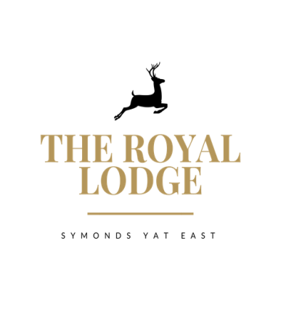

THE LODGE’S DEVIL TABLE D’HOTE MENU
STARTER ONLY £9.95; MAIN ONLY £18.95; DESSERT ONLY £8.95
STARTERS
Chicken Liver Pate, Onion Jam, Toast (W, Sul, M)
Herb Crusted Mushroom Stack with Sun Blushed Tomatoes and Red Pepper, rocket (M, W)
Prawn and Crayfish Cocktail, Little Gem (Cr, F, W, M,)
Jackfruit Crab cakes with Chilli & Lime Mayo (Vegan, W)
Breaded Brie, Cranberry Jam, Salad, balsamic reduction (W, M, Sul)
Asparagus and Tenderstem Leek wraps with Citrus Aioli (Vegan)

MAINS
Mains are served with Your Choice of Chips (W), New, Sauteed or Dauphinoise Potatoes(M)
Cajun Chicken Breast, Garlic & Lemon Butter Sauce, Mixed Salad (M,)
Mushroom Wellington, Mixed Salad & Spring Onion, Red Pepper, Couscous (W, M)
Double Homemade Welsh Black Beef Burger in Brioche Bun (W, E, M, Mu, Sul)
Mature Cheddar, Smoked Bacon, Mayonnaise, Gem Lettuce, onion jam
Breaded Scampi Mixed Salad, Garden Peas & Tartar Sauce (F, G, M)
Wye Valley Beer Battered Fish Fillet Mixed Salad, Garden Peas & Tartar Sauce (F, G, M)
Roasted Cauliflower Steak with Smoked Tomato Sauce Cauli Bhajis and Herb Oil (Vegan)

DESSERTS
Lucas Oreo Chocolate Mousse Cheesecake with Fruit Coulis (Sul, M, W)
Vanilla Crème Brulee with Caramelised Figs, Shortbread (M, W, E, V)
Apple & Mixed Berry Crumble with Cream or Custard or Ice cream (M, E, V, GF)
Cheese Plate Cheddar, Brie & Stilton with Crackers, Butter, Grapes and Celery (M, C, W, Mu, S, N, V)
Sticky Toffee Pudding Toffee Sauce (M, W, E, V)
Chocolate Torte with Cherry Coulis (M, W)

STARTER AND MAIN £27.95, MAIN AND DESSERT £26.95, STARTER, MAIN AND DESSERT £36.95
An optional 10% service charge will be added to your bill
ALLERGENS
C=Celery, L=Lupin, N=Nut, Sul=Sulphur Dioxide, Cr=Crustacean, M=Milk, So=Soya P=Peanut, W=Wheat, E=Egg, Mol=Mollusc, S=Sesame, V=Vegetarian, F=Fish, Mu=Mustard:

