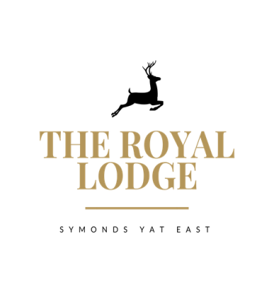

SAMPLE LODGE TABLE D’HOTE MENU
STARTER ONLY £9.95; MAIN ONLY £18.95; DESSERT ONLY £8.95
STARTERS
Chicken Liver Pate, Onion Jam, Brown Toast (W, Sul, M)
Herb Crusted Mushroom Stack with Sun Blushed Tomatoes and Salad (M, W)
Prawn and Crayfish Cocktail, Little Gem (Cr, F, W, M,)
Quinoa with Orange Segments, Beetroot and Herbs (Vegan, W)
Breaded Brie, Cranberry Jam, Salad (W, M)

MAINS
Mains are served with Your Choice of Chips, New, Sauteed Or Dauphinoise Potatoes
8oz Grilled Gammon, Pineapple, Tomato and Salad (Sul)
Mushroom Wellington, Mixed Salad & Spring Onion Couscous (W, M)
Double Homemade Welsh Black Beef Burger in Brioche Bun (W, E, M, Mu, Sul)
Mature Cheddar, Smoked Bacon, Mayonnaise, Gem Lettuce
Breaded Scampi Mixed Salad, Garden Peas & Tartar Sauce (F, G, M)
Wye Valley Beer Battered Fish Fillet Mixed Salad, Garden Peas & Tartar Sauce (F, G, M)

DESSERTS
Red Wine Poached Pear with Chantilly Cream (Sul, M, V)
Vanilla Crème Brulee with Caramelised Figs, Shortbread (M, W, E, V)
Apple & Mixed Berry Crumble with Cream or Custard or Ice cream (M, E, V, GF)
Cheese Plate Cheddar, Brie & Stilton with Crackers, Butter, Grapes and Celery (M, C, W, Mu, S, N, V)
Sticky Toffee Pudding Toffee Sauce (M, W, E, V)

STARTER AND MAIN £27.95
MAIN AND DESSERT £26.95
STARTER, MAIN AND DESSERT £36.95
An optional 10% service charge will be added to your bill
ALLERGENS
C=Celery, L=Lupin, N=Nut, Sul=Sulphur Dioxide, Cr=Crustacean, M=Milk, So=Soya P=Peanut, W=Wheat, E=Egg, Mol=Mollusc, S=Sesame, V=Vegetarian, F=Fish, Mu=Mustard:

