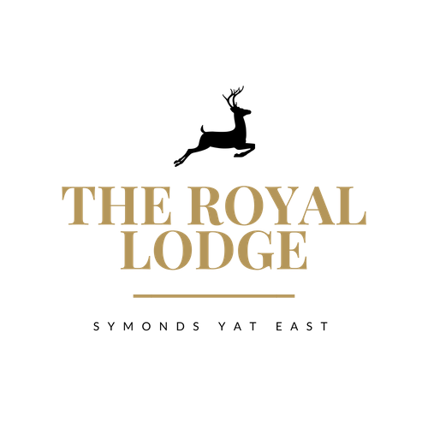

SAMPLE SNACK MENU
Baguettes
Colliers Mature Cheddar & Pickle Chutney (M, Mu, C, W)£11.95
Home Honey Roasted Ham & Mustard (W, Sul, Mu) £11.95
Tuna & Cucumber with Mayonnaise (W, F, E) £11.95
Roast Beef & Horseradish (W, Sul, Mu, M) £11.95
Avocado, Rocket, Roasted Peppers (V, W) £11.95
A Choice of Brown, White or Gluten Free Bread Served with Mixed Seasonal Salad and a Handful of Plain Crisps.
Lodge Shire Lunch (M,W,E,Mu,C,Sul)
Choice of Home Cooked Honey Roast Ham or Mature Cheddar or Both, Served with Pickled Onions, Grated Carrot, Pork pie and Tomato Salad with White or Brown Crusty Baguette £16.95

Bowl of Homemade Chips £4.75 Cheesy Chips £4.95 SOUP
Tomato and Basil soup (C, V, VEGAN) Crusty Bread (W, M) £8.50
ALLERGENS:
C=Celery, L=Lupin, N=Nut, Sul=Sulphur Dioxide, Cr=Crustacean, M=Milk, So=Soya P=Peanut, W=Wheat, E=Egg, Mol=Mollusc, S=Sesame, V=Vegetarian, F=Fish, Mu=Mustard
An Optional 10% service charge will be added to your bill

SAMPLE SNACK MENU
Baguettes
Colliers Mature Cheddar & Pickle Chutney (M, Mu, C, W)£11.95
Home Honey Roasted Ham & Mustard (W, Sul, Mu) £11.95
Tuna & Cucumber with Mayonnaise (W, F, E) £11.95
Roast Beef & Horseradish (W, Sul, Mu, M) £11.95
Avocado, Rocket, Roasted Peppers (V, W) £11.95
A Choice of Brown, White or Gluten Free Bread Served with Mixed Seasonal Salad and a Handful of Plain Crisps.
Lodge Shire Lunch (M,W,E,Mu,C,Sul)
Choice of Home Cooked Honey Roast Ham or Mature Cheddar or Both, Served with Pickled Onions, Grated Carrot, Pork pie and Tomato Salad with White or Brown Crusty Baguette £16.95

Bowl of Homemade Chips £4.75 Cheesy Chips £4.95 SOUP
Tomato and Basil soup (C, V, VEGAN) Crusty Bread (W, M) £8.50
ALLERGENS:
C=Celery, L=Lupin, N=Nut, Sul=Sulphur Dioxide, Cr=Crustacean, M=Milk, So=Soya P=Peanut, W=Wheat, E=Egg, Mol=Mollusc, S=Sesame, V=Vegetarian, F=Fish, Mu=Mustard
An Optional 10% service charge will be added to your bill

