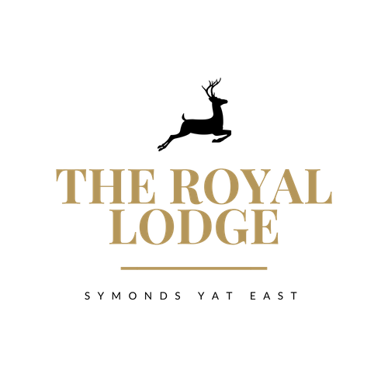

Continental Breakfast Adult - £10.95 Child- £8.95

Included is Cereal, Fruit Juice, Tea or Coffee, Pastry, Fruit Salad, Toast
Juice: Orange or Apple juice
Hot Beverage: Tea, Coffee
Toast: White (W) Brown (W) Butter (M) Jam or Marmalade

Cereals: Crunchy Nut (G,W,M,N,P) Rice Krispies(W,N,M,G)
Corn Flakes (W, M, So) Weetabix (W,M) Alpen (W,M,N

Pastries: Croissant (W,M,E,V) Pain au chocolat (W,M,E,V)
Fresh Fruit Salad

BREAKFAST ORDER FULL MONTY:

FULL MONTY: Continental and Cooked Breakfast Adult - £15.95 Child- £11.95
(Please ask a member of staff if breakfast is included in your reservation)
Includes The Lodge Continental Breakfast and Full Cooked Breakfast
Cooked Breakfast:
Smoked Back Bacon, Pork Sausage (W,E,M), Mushrooms (M,V)
½ Roasted Tomato (V) Hash Brown (V) Fried bread (W,V)
Baked Beans (V) Fried / Scrambled / Poached Egg (E,V)
Gluten free Sausage (E) Vegetarian Sausage (So, W)

OR
Smoked Scottish Salmon & Scrambled Egg (F, E, M)

Continental Breakfast Adult - £10.95 Child- £8.95

Included is Cereal, Fruit Juice, Tea or Coffee, Pastry, Fruit Salad, Toast
Juice: Orange or Apple juice
Hot Beverage: Tea, Coffee
Toast: White (W) Brown (W) Butter (M) Jam or Marmalade

Cereals: Crunchy Nut (G,W,M,N,P) Rice Krispies(W,N,M,G)
Corn Flakes (W, M, So) Weetabix (W,M) Alpen (W,M,N

Pastries: Croissant (W,M,E,V) Pain au chocolat (W,M,E,V)

Fresh Fruit Salad

BREAKFAST ORDER FULL MONTY:

FULL MONTY: Continental and Cooked Breakfast Adult - £15.95 Child- £11.95
(Please ask a member of staff if breakfast is included in your reservation)
Includes The Lodge Continental Breakfast and Full Cooked Breakfast
Cooked Breakfast:
Smoked Back Bacon, Pork Sausage (W,E,M), Mushrooms (M,V)
½ Roasted Tomato (V) Hash Brown (V) Fried bread (W,V)
Baked Beans (V) Fried / Scrambled / Poached Egg (E,V)
Gluten free Sausage (E) Vegetarian Sausage (So, W)

OR
Smoked Scottish Salmon & Scrambled Egg (F, E, M)

