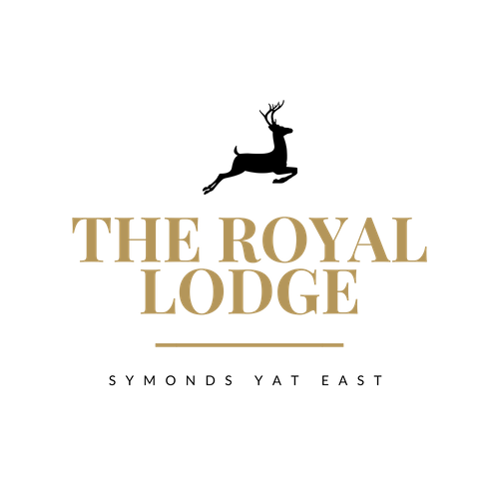

SAMPLE GARDEN TEA MENU
Coffee & Cake slice of Victoria Sponge, Carrot Cake or Lemon Drizzle with a Hot Beverage £5.95

Tea & Toasted Teacakes Two Teacakes with Strawberry jam, Butter and a Hot Beverage £7.50

Royal Lodge Cream Tea with Hot Beverage of Your Choice £11.95
Includes Two Fruit Scones, Served with Clotted Cream, Strawberry Jam & Butter.

Sparkling Cream Tea £17.95 or £33.95 for Two Sharing
Includes Two Fruit Scones, Served with Clotted Cream, Strawberry Jam & Butter.
Accompanied with a Hot Beverage of your choice & a 200ml Bottle of Prosecco

Royal Lodge Afternoon Tea £17.95 or £33.95 for Two Sharing
A Choice of Homemade Sandwich, Two Fruit Scones, Clotted Cream, Strawberry Jam, Butter and
a Selection of Victoria Sponge, Carrot Cake and Lemon Drizzle Cake.
. Accompanied with a Hot Beverage of Your Choice

Sparkling Afternoon Tea £25.95 or £49.95 for Two Sharing
A Choice of Homemade Sandwich, Two Fruit Scones, Clotted Cream, Strawberry Jam, Butter and
a Selection of Victoria Sponge, Carrot Cake and Lemon Drizzle Cake.
. Accompanied with a Hot Beverage of Your Choice and a 200ml Bottle of Prosecco Each
Sandwich Filling Choices;

Tuna Mayonnaise ⋅ Salmon & Cream Cheese ⋅Colliers Cheddar & Pickle ⋅
Ham & Mustard- Beef & Horseradish
Served on either White or Wholemeal Bread, Gluten Free Also Available
Allergens: C, E, G, M, Mu, N, P, S, SUL

ALLERGENS
C=Celery, L=Lupin, N=Nut, Sul=Sulphur Dioxide, Cr=Crustacean, M=Milk, So=Soya P=Peanut, W=Wheat, E=Egg, Mol=Mollusc, S=Sesame, V=Vegetarian, F=Fish, Mu=Mustard:

An optional 10% service charge will be added to your bill

