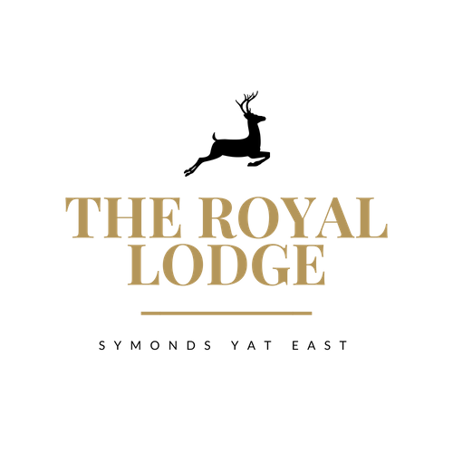

Dear Both,

Congratulations on your engagement and thank you for your valued enquiry to host your special day here with us here at The Royal Lodge, Symonds Yat East.

The Lodge has an idyllic setting in the heart of the Wye Valley, an area of outstanding natural beauty, where the river cuts through a wooded gorge on the edge of the spectacular Forest of Dean. The Lodge is nestled just below Symonds Yat Rock and stands exclusively in the grounds of almost 5 acres overlooking the river, the perfect setting for your special day.

The Lodge has an indoor function suite combined with a fantastic raised lawn which is perfect for a marquee overlooking the River Wye. We also offer our fully licensed outdoor wooden pergola for your special ceremony with a difference.

In this pack you will find a sample of our wedding menus, should you have any special requirements for your menu please let us know, all dietary needs and requests are catered for. All of our menu offerings are homemade; where possible we use local produce.

The Lodge can offer discounted venue fees for mid-week weddings. Venue fees vary dependant on the elements chosen, numbers of persons attending as well as the time of day, day of the week & time of the year that you choose for your special day.

Services that can be arranged include –river cruises along the River Wye and music services such as bands or DJ’s.

Please call us to arrange an appointment with our in house wedding co-ordinator, who would be delighted to show you around the venue to discuss your wedding details & requirements.

We look forward to hearing from you.

Wedding Packages Can Include:

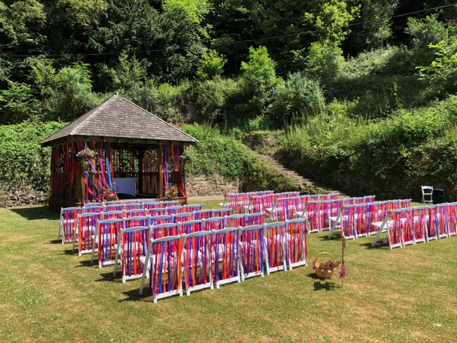
Exclusive or Non Exclusive Venue Hire

Ceremony – Choose either an outdoor or indoor
Ceremony

Banqueting Set up & Service Staff
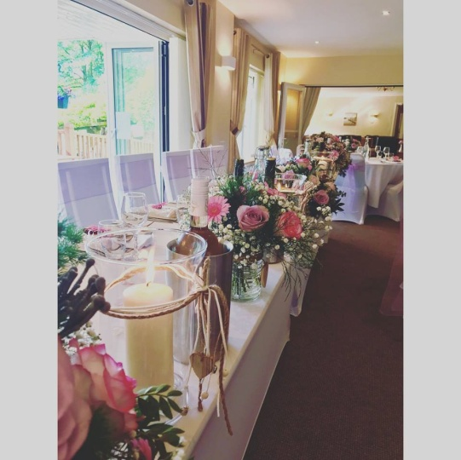
Welcome Drinks

Table Numbers & Name Cards

Three Course Wedding Breakfast

Organic Wine with Dinner

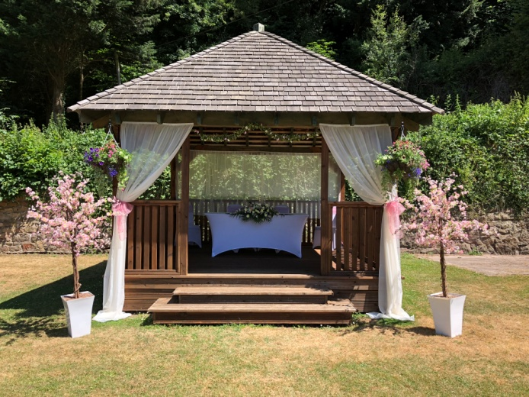
Organic Cava for Speeches

Chair Covers & Sashes – Charges Apply

Table Linen & Napkins – Charges Apply

For more information and prices please contact our wedding coordinator who will
Gladly assist you with a personalised quote.
Drinks Packages

Bronze £18.95pp
Pre-Reception Drinks
(served after the ceremony if held at The Royal Lodge or on arrival for church weddings)
Fruit Juice Selection & Filtered Bottled Water
Glass of Organic Wine or Sangria served with Wedding Breakfast
Glass of Organic Cava served for speeches

Silver £21.95pp
Pre-Reception Drinks
Organic Cava, Fruit Juice Selection & Filtered Bottled Water
Glass of Wine or Sangria served with Wedding Breakfast
Glass of Organic Cava served for speeches

Gold £25.95pp
Pre-Reception Drinks
Pimms & Lemonade, Fruit Juice Selection & Filtered Bottled Water
Two Glasses of Wine or Sangria served with Wedding Breakfast
Glass of Organic Cava served for speeches

Canapés from £11.95 pp
Min 20 Persons
Choose any three from below, upgrade to six for additional £2.95pp:

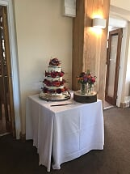
Vegetable Spring Rolls (V, C, M, W, E, S)
Smoked Salmon Bellini (M, W, E, F)
Caerphilly Welsh Rarebit Brioche (V, M, W, E, MU)
Smoked Bacon and Brie Crostini (M, W, E)
Gourmet Sausages on Sticks (W, E, MU)
Beetroot Bellini (V, W, E)
Prawn Sushi Roll (CR, M, W, E, S, F)
Chicken Liver Parfait Crostini (SUL, M, W, E)

Sample Royal Wedding Menu
£37.95 pp based on min 30 persons, please choose three dishes per course to offer your guests

Royal Starters

Home-made Tomato & Basil Soup (C, W, E)
with crusty bread & croutons
Homemade Chicken Liver Parfait (SUL, M, W, E)
with seasoned baby leaf salad, onion marmalade and toasted bread
Garlic Butter Mushrooms (V, M, W, E)
in a filo pastry nest
Homemade Leek and Brie Tart (V, M, W, N)
with rocket and toasted pine nuts
Marinated Lamb Kofta (M, W)
with a homemade tzatziki dressing
Classic Royal Prawn Cocktail (M, E, CR, W)
served simply with lemon salad and malted toast

Royal Main Courses
(All Served with Carrot, Mixed Greens and Cauliflower Medley)
Royal Orchard Roasted Pork Belly (C, SUL, W, E)
with roasted potatoes and sage & onion stuffing
Roasted Chicken Breast (SUL, C, M)
with sautéed potatoes and Madeira jus
Poached Fillet of Salmon (M, F)
with new potatoes and lemon & herb butter
Confit Duck Leg (C, W, SUL)
with a spring onion potato cake and royal plum sauce
Cheddar and Tomato Risotto (V, M)
in a Roasted Pepper Shell

Royal Desserts

Homemade Lemon Cheesecake (M, W)
with a berry coulis
Royal Poached Pear (SUL, M)
with chantilly cream
Lodge Berry Brulée (M, W, E)
with homemade shortbread
Royal Bread and Butter Pudding (M, W, E)
with creme anglais
Sample Platinum Wedding Menu
£47.95 pp based on min 30 persons, please choose three dishes per course to offer your guests

Platinum Starters

Homemade Roasted Butternut Squash Soup (V, C, W)
with crusty bread and crème fraîche
Pant ys Gawn Goats Cheese and Red Onion Tartlet (V, SUL, W, E, M)
Homemade Ham Hock Terrine (SUL, MU, M, E)
with piccalilli and toasted loaf
Home Smoked Duck Breast (N, M, E)
with waldorf salad and honey dressing
Crayfish and Lemon Mayonnaise Bruschetta (CR, E, M, W, F)
with sun blushed and red onion salad
Chicken and Chorizo Skewers (SUL, W)
served with tomato and pearl couscous

Platinum Main Courses
(All Served with Carrot, Mixed Greens and Cauliflower Medley)
Royal Herefordshire Roast Beef (W, C, SUL, M, E, W)
with goose fat roast potatoes and Yorkshire pudding
Homemade Chorizo Stuffed Chicken Breast (W, M, SUL)
with garlic parmentier potatoes & mange tout
Roasted Atlantic Cod (F, M)
with creamed potato, pancetta and pea puree
Roasted Pork Loin (M)
with dauphinoise potatoes and tarragon cream sauce
Wild Mushrooms, Spinach and Roasted Peppers, Thyme,
Butternut Squash & Leek Ribbons (V, M)

Platinum Desserts

Baileys White Chocolate Cheesecake (M, W)
with fresh fruit coulis
Vanilla Panacotta (M, W)
with homemade shortbread
Apple Tarte Tatin (M, W)
with toffee sauce
Sticky Toffee Pudding (M, W)
with butterscotch sauce & vanilla ice cream
Garden Menu
From £17.95 pp based on min 30 persons
Selection of homemade bridge rolls
Served on white and brown bread with the following fillings:
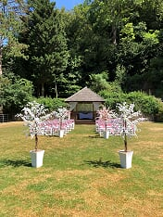
Egg mayonnaise & watercress
(E, M, W)
Mild cheddar & Sweet pickle
(SUL, M, W)
Honey Roast Ham & Mustard
(M, MU, W)
Smoked Salmon & Cream Cheese
(F, M, W)
Homemade Quiche’s
(MU, C, M, W, E, V)

Warm homemade Scones
(E, V, M, SUL, W)
Served with Strawberry Jam & Clotted Cream

Selection of delicious homemade Cakes:

Classic Victoria Sponge (SUL, M, W, E, V)
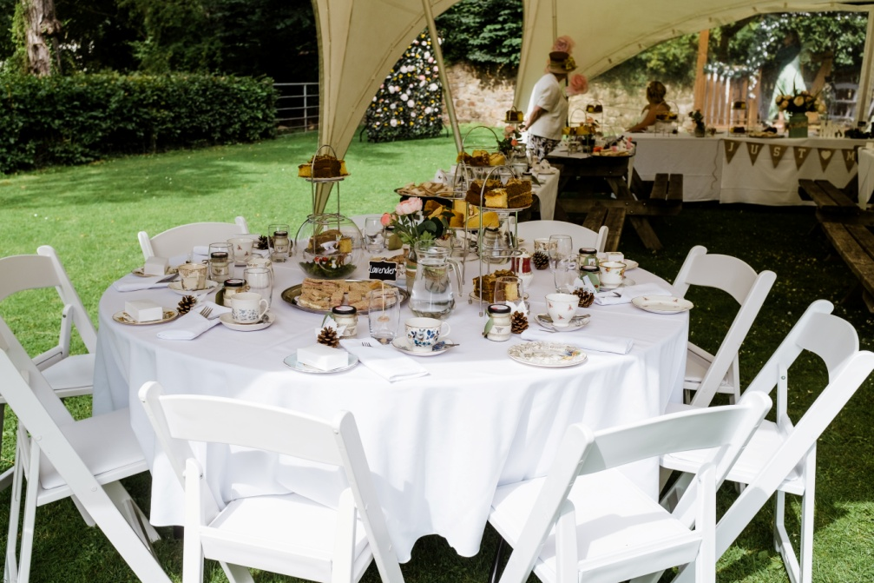
Lemon Drizzle (M, E, W)
Coffee & Walnut (B, N, W, E, M, V)
Lemon & Raspberry (M, E, W, V)
Cherry Bakewell (M, E, W, N, V)
Carrot Sponge (W, M, N, E, V)
Chocolate Brownie (M, W, E, V)

Garden additions

Garden Chairs £1.95 Each
Garden Gazebo £99 (size 3m x 5.40m)
Marquee £POA
Evening Buffet
From £16.95 pp based on min 30 persons
Please Choose One of the Below

Traditional Buffet (C, M, W, E, MU) £16.95

Assiette of Sandwich Platters on White and Granary Bread Served with Fresh Crudities, Dips, Jacket Wedges, Homemade Sausage Rolls, Royal Lodge Quiche, Potato Salad and Fragrant Fruity Couscous

Street Food Buffet (F, M, W, E) £18.95 pp

Royal Mini Fish and Chip Cones, Lodge Mini Beef Burgers, Potato Wedges, Homemade Beetroot and Chickpea Burgers All Served with Lodge Relishes, Salads, Breadsticks and Selection of Dips

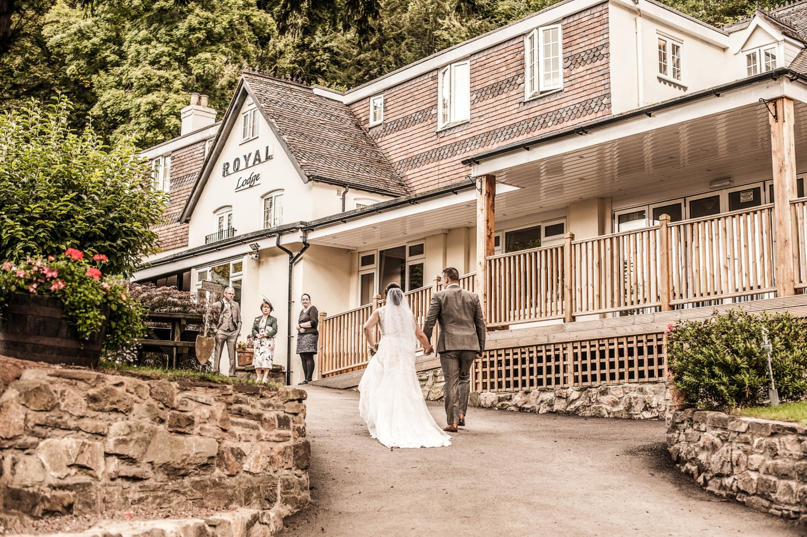

Evening Options
Hot and Cold Traditional (C, W, E, M)
From £20.95 pp based on min 30 persons

Assiette of Sandwich Platters on White and Granary Bread Served with Fresh Crudities, Dips, Roasted New Potatoes, Homemade Gourmet Sausage Rolls, Chilli Beef Parcels, Potato Salad with Spring Onions and Fine Beans, Fragrant Fruity Couscous, Chicken & Chorizo Kebabs and Lamb Kofta Kebabs

Lodge Hog Roast and BBQ (C, W, E, M)
From £25.95 pp based on min 60 persons

Local Herefordshire Pig Roast with Homemade Apple Sauce, Sage Stuffing, Seasonal Salad, Brioche Buns, Beef Burgers, Gourmet Sausages and Red Pepper & Halloumi Kebabs
All Served with Selection of Salads, Crudities and Dips

