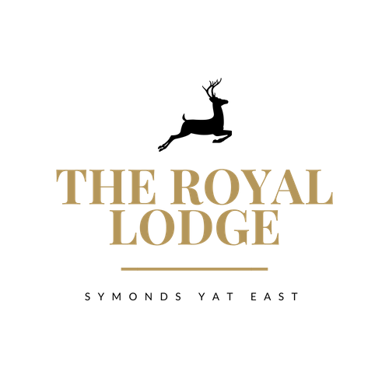

House Special
Starter
Pappardelle, Wild Mushrooms, Pesto,
Parmesan Cheese £8.95
White Wine Cream Sauce, Rocket (W,M,E,V,N)
Main course
Slow Braised Welsh Lamb Shank £21.95
Rosemary Gravy, Truffle Mash, Buttered Spinach,
Chargrilled Tenderstem Broccoli (C,S,M,W)
side
Creamy Celeriac and thyme puree £3.95
(M)
Dessert
Banana bread and butter pudding £7.95
Custard (M,W,E)

House Special
Starter
Pappardelle, Wild Mushrooms, Pesto,
Parmesan Cheese £8.95
White Wine Cream Sauce, Rocket (W,M,E,V,N)
Main course
Slow Braised Welsh Lamb Shank £21.95
Rosemary Gravy, Truffle Mash, Buttered Spinach,
Chargrilled Tenderstem Broccoli (C,S,M,W)
side
Creamy Celeriac and thyme puree £3.95
(M)
Dessert
Banana bread and butter pudding £7.95
Custard (M,W,E)

