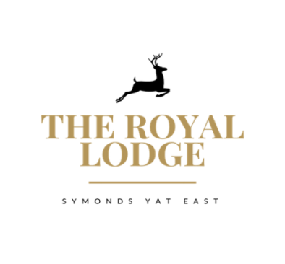

Lodge Daily Kitchen Menu
AVAILABILITY OF SOME DISHES MAY BE LIMITED
Please check at the bar or with your server

Starters
Textures of cauliflower (puree, spiced pickled, battered, grilled) (W,M,N) £8.95 Served with Pesto & Parmesan
Fishcakes (CR,E,N,F,W,M) Served with Pine nut mayo and char-grilled tender stem broccoli £8.95
Grilled King Prawns In shell (CR,W,E,F,M) Served with Chilli, Ginger herb butter and crusty bread £8.95
Charcuterie and meats & Parma ham ( E,W,M,Mu,Sul) £8.95 Mixed olives, homemade bread, olive oil, balsamic vinegar

Mains

Grilled Welsh Lamb Cutlets (C,W,M,Sul) £19.95
Served with Dauphinoise potato and Parsnip puree
Slow braised Welsh lamb shank in garlic and rosemary red wine (C,W,M,Sul) £19.95
Served with Garlic herb mash and honeyed roasted roots
Grilled fillet of Cod (Cr,F,M,Sul) £19.95
With a Herb and parmesan crust, chorizo, rosti and cauliflower puree

Orchard pork belly (C,M,Sul, E,Mu) £19.95
Served with a Black pudding bonbon, chive mash, braised red cabbage, cider cream sauce

1 Course £19.95
2 Courses £26.95
3 Courses £32.95

