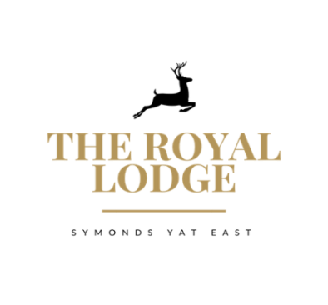

Bar Nibbles Menu

Cheese Nibbles Light Bites
60g per serving. All served with cheese biscuits, celery & homemade chutney.

C, W, M, Mu, N, S,

BLACK BOMBER
Creamy & smooth extra mature cheddar, loved for its depth of flavour ……………………………………………...£6.95

PERL WEN
Creamy, brie-style cheese. Soft and succulent with a citrus centre, enjoy with a crisp white wine …………………………………………………………………….…£6.95

PERL LAS
A superb welsh blue cheese, golden in colour, with a creamy & gently salty taste that grows stronger with maturity …………………………..……………………………. £6.95

Y-FENNI
Welsh cheese, consisting of Cheddar cheese blended with mustard seed and ale.………….…………………… £6.95
Garlic breads (W, M)
Homemade garlic bread
£3.95

Homemade garlic bread topped with cheese M,W
£4.95

To share (W, C, M, Mu, Sul)
Charcuterie meat & Parma ham
£14.95
All served from the kitchen

Smoked salmon & cream cheese Bellini’s
(M, F, E, W)
………………………………………………………………… £4.25

Parma ham with mayo & rocket on toasted bread
(M, E, W)
………………………………………………………………… £4.25

Salami & sweet chilli jam on toasted bread
(E, W, M, Sul, S)
………………………………………………………………… £4.25

Marinated olives with picking sticks (Sul, N)
………………………………………………………………… £3.25

Selection of bread sticks (W, M, S) ………………………………………………………………… £3.75

In house baked bread with olive oil and balsamic vinegar (E, M, W,Sul) ……………………………………………………£4.95

