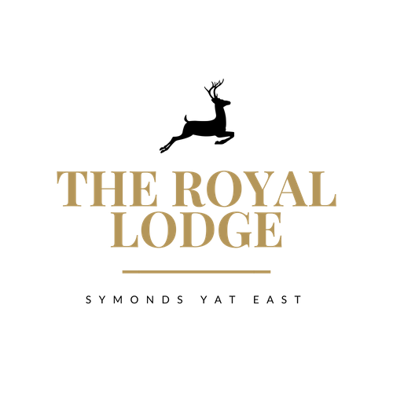

Afternoon Menu
Served 12.00pm to 5.00pm daily
Coffee & Cake £5.25
Choose a slice of cake from our selection, with a Hot Beverage of your choice

Tea & Toasted Teacakes £6.95
Two teacakes served with strawberry jam and butter with a Hot Beverage of your choice

Royal Lodge Cream Tea £8.95
Includes Two Homemade Fruit Scones, Served with Clotted Cream, Strawberry Jam & Butter. Accompanied with a Hot Beverage of your choice

Sparkling Cream Tea £16.95 or £32.95.00 for Two Sharing
Includes Two Homemade Fruit Scones, Served with Clotted Cream, Strawberry Jam & Butter. Accompanied with a Hot Beverage of your choice & a 200ml Bottle of Prosecco

Royal Lodge Afternoon Tea £16.95 or £33.95 for Two Sharing
A Choice of Homemade Sandwich, Two Homemade Fruit Scones, Clotted Cream, Strawberry Jam, Butter & a Selection of Two Cakes. Accompanied with a Hot Beverage of Your Choice

Sparkling Afternoon Tea £24.95 or £39.95 for Two Sharing
A Choice of Homemade Sandwich, Two Homemade Fruit Scones, Clotted Cream, Strawberry Jam, Butter & a Selection of Two Cakes. Accompanied with a Hot Beverage of Your Choice & a 200ml Bottle of Prosecco

Sandwich Fillings;
Tuna Mayonnaise ⋅ Salmon & Cream Cheese ⋅ Cheese & Pickle ⋅ Ham & Mustard-
Served on either White or Whole meal Bread

C, E, G, M, Mu, N, P, S, SUL

