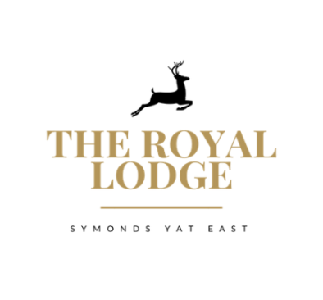
SPECIALS MENU

AVAILABILITY OF SOME DISHES MAY BE LIMITED PLEASE
CHECK AT THE BAR OR WITH YOUR SERVER

Lamb and garlic kebab £7.95
Grilled halloumi, minted sour cream, spring onion and cucumber salad

Slow roasted chicken leg in chilli and apricot (very spicy) £7.95
Coriander yoghurt

Pan seared Mackerel £8.25
Curried lentil puree, tomato concasse, Toasted Almond

To share

Charcuterie and meats & Parma ham £15.95
Mixed olives, homemade bread, olive oil, balsamic vinegar

Mains

Basil, pumpkin, spinach gnocchi £16.95
Spinach cream sauce, Chargrilled tender stem broccoli, , roasted beetroot,
buttered broad bean, parmesan cheese

Oven roasted darne of salmon £18.95
Sage rosti, pea puree, hollandaise

Hot meat platter for 2 people £39.95
Lamb and mint kebab, sweet chilli glazed gammon steak, local pork sausage,
red onion jam, spicy chicken leg, coriander yoghurt, chargrilled baby sweet corn ,
garlic sweet potato wedges

