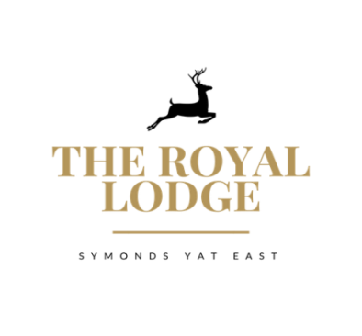

Homemade Dessert Menu

Herefordshire Strawberries £7.95
Clotted Cream and Chantilly Cream

Vanilla Creme Brulee £8.25
Chocolate and salted caramel ice cream

Sticky Toffee Pudding £8.25
Toffee Sauce, Vanilla Ice cream

Selection of Local Ice Cream Choice of 3 Scoops £7.95
Triple Chocolate, Vanilla, pistachio, rhubarb and custard, Cappuccino, Lemon curd Meringue,
white chocolate and morello cherry, mint choc chip, Chai latte

Trio of Sorbet £7.95
Lemon, Orange, Quince (Apple)

Lemon Cheesecake £7.95
Mixed Berry Compote

Orange and marmalade bread and butter pudding £8.25
Served With Custard

Natural vanilla bean ice cream £7.95
Herefordshire Strawberries £7.95

The Royal Lodge Cheese Slate £13.95
Pearl Wen (brie), Worcestershire honey and fig, Black Bomber,
Perl Las, Served with Crack Pepper and Smoked Sea Salt Butter, Quince Jelly,
Fruit Chutney, Grapes, Celery and Mixed Biscuit Selection

