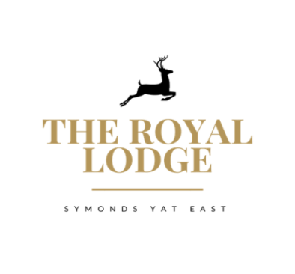

Lodge Bar Nibbles Menu

Cheese Nibbles Light Bites
Garlic breads
Homemade garlic bread
£4.25

Homemade garlic bread topped with cheese
£4.95

To share
Charcuterie meat & Parma ham
£14.95
All served from the kitchen

Smoked salmon & cream cheese Bellini’s
………………………………………………………………… £4.95

Parma ham with mayo & rocket on toasted bread
………………………………………………………………… £4.95

Spicy salami & sweet chilli jam on toasted bread
………………………………………………………………… £4.95

Marinated olives with picking sticks
………………………………………………………………… £4.95

Selection of bread sticks with hummus
………………………………………………………………… £4.25

Toasted bread with olive and balsamic vinegar
………………………………………………………………… £4.95

60g per serving. All served with cheese biscuits, celery & homemade chutney.

BLACK BOMBER
Creamy & smooth extra mature cheddar, loved for its depth of flavour ……………………………………………...£6.95

PERL WEN
Creamy, brie-style cheese. Soft and succulent with a citrus centre, enjoy with a crisp white wine …………………………………………………………………….…£6.95

PERL LAS
A superb welsh blue cheese, golden in colour, with a creamy & gently salty taste that grows stronger with maturity …………………………..……………………………. £6.95

WORCESTER
Flaky texture and a straw yellow interior with flavours of a citrus tang ………………………………… £6.95

