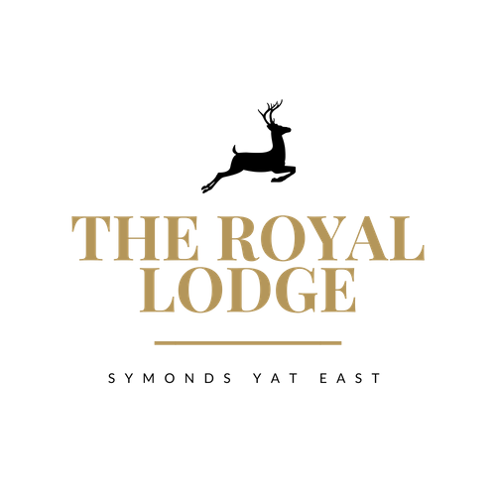

Afternoon Menu
Served 12.00pm to 5.00pm daily

Coffee & Cake £5.25
Choose a slice of cake from our selection, with a Hot Beverage of your choice

Royal Lodge Cream Tea £8.95
Includes Two Homemade Fruit Scones, Served with Clotted Cream, Strawberry Jam & Butter. Accompanied with a Hot Beverage of your choice

Sparkling Cream Tea £27.00 for Two Sharing
Includes Two Homemade Fruit Scones, Served with Clotted Cream, Strawberry Jam & Butter. Accompanied with a Hot Beverage of your choice & a 200ml Bottle of Prosecco

Royal Lodge Afternoon Tea £13.95 or £25.95 for Two Sharing
A Choice of Homemade Sandwich, Two Homemade Fruit Scones, Clotted Cream, Strawberry Jam, Butter & a Selection of Two Cakes. Accompanied with a Hot Beverage of Your Choice

Sparkling Afternoon Tea £19.95 or £37.95 for Two Sharing
A Choice of Homemade Sandwich, Two Homemade Fruit Scones, Clotted Cream, Strawberry Jam, Butter & a Selection of Two Cakes. Accompanied with a Hot Beverage of Your Choice & a 200ml Bottle of Prosecco

Sandwich Fillings;
Tuna Mayonnaise ⋅ Salmon & Cream Cheese ⋅ Cheese & Pickle ⋅ Ham & Mustard
Served on either White or Wholemeal Bread

