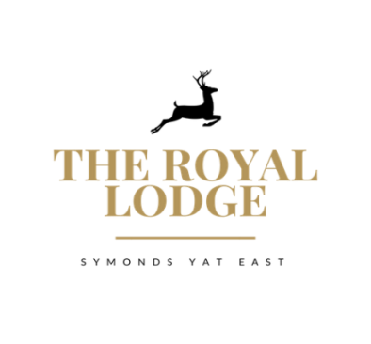
BAR NIBBLES MENU

Marinated Olives With Picking Sticks £2.95

Selection Of Breadsticks with Hummus £3.25

Smoked Salmon & Cream Cheese Bellinis £3.95

Parma Ham & Rocket Mayo on Toasted Bread £3.95

Spicy Salami & Tomato Chutney on Toasted Bread £3.95

Toasted Bread with Olive Oil and Balsamic Vinegar £4.50

Garlic Bread £3.75

Garlic Bread With Cheese £4.25

TO SHARE

Charcuterie Meats & Parma Ham
Mixed Olives, Homemade Bread, Olive Oil, Balsamic Vinegar £14.95
Selection Of Crisps and Nuts Available from the Bar

AVAILABLE TO ORDER BETWEEN 12 NOON AND 9 PM

