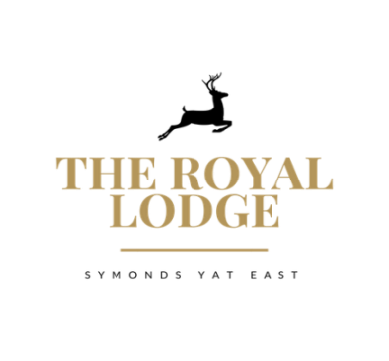

Menu Specials

Starters

Filo Pastry, Heritage Tomato & Caramelised Onion £7.95
smoked cheese, chargrilled baby leek, sweet red pepper syrup

Pan Seared Scallop £9.50
Avocado, jalapeno Butter, tomato and pepper Salsa, coriander, Boc choi

To Share
Charcuterie Meats & Parma Ham £14.95
Mixed Olives, Homemade Bread, Olive Oil, Balsamic Vinegar

Mains

Pesto Arancini, Broad Beans £14.95
carrot puree, thyme roasted heritage carrot, crispy sage, black olive tapenade

Herb Crusted Welsh Lamb Cannon £23.95
Dijon Mustard, Herb Rosti, Charred Baby Leeks, Sugar Snap, Madeira Jus,
(Pink Cooked only)

Huntcham Farm Middle White pork Sausage, Parma Ham Crisp £15.95
Chive mash, Chargrilled Tender Stem Broccoli, Onion gravy

Oven Roasted Whole Lemon Sole £24.95
Buttered and Herb New Potato, Samphire, Lemon and Herb Butter

Tiger Prawn, Spring Onion and pea Risotto £17.95
Sweet Chilli Jam, Crispy Leeks

