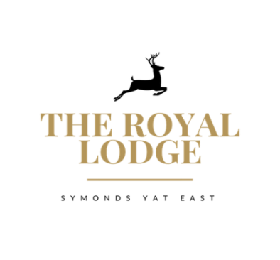

Dessert Menu

Herefordshire Strawberries £7.95
Clotted Cream and Chantilly Cream Caramel Coco Nibs

Sticky Toffee Pudding £7.95
Toffee Sauce, Vanilla Ice cream

Berry Eton Mess £7.95
Selection of Local Ice Cream Choice of 3 £7.95
Triple Chocolate, Vanilla, Strawberry, Honeycomb, Cappuccino, Lemon curd Meringue,
white chocolate and morello cherry, mint choc chip

Trio of Sorbet £7.95
Lemon, Passion Fruit, Quince (Apple)

Lemon Cheesecake £7.95
Berry Compote

Chocolate Brownie £7.95
Chai latte Ice Cream

Royal Lodge Cheese Slate £13.95
Pearl Wen (brie), Worcestershire honey and fig, Black Bomber, Perl Las, Served with Crack Pepper and Smoked Sea Salt Butter, Quince Jelly, Fruit Chutney, Grapes, Celery and Mixed Biscuit Selection

